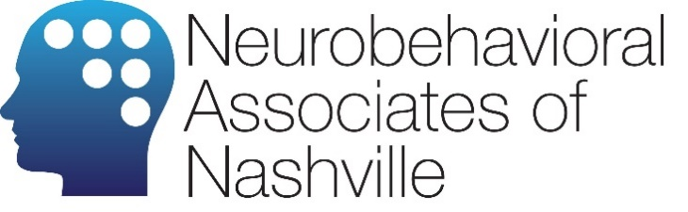 | 40 Burton Hills Blvd, Suite 200  Nashville, TN 37215  (615) 761-9925  Discover the Power of the Mind

2022 Costs & Codes

Neuropsychological Evaluation
Service | Cost | CPT Code
Clinical Interview/Testing 1st hour | $200 | 96132
Testing | $1300 | 96133

Learning Disability Evaluation
Service | Cost | CPT Code
Clinical Interview/Testing 1st hour | $200 | 96130
Testing | $1800 | 96131

ADD/ADHD Evaluation
Service | Cost | CPT Code
Clinical Interview | $200 | 96130
Testing | $500 | 96131

Psychological Evaluation
Service | Cost | CPT Code
Clinical Interview | $200 | 96130
Testing | $500 | 96131

Neurofeedback
Service | Cost | CPT Code
Clinical Interview | $200 | 90791
Functional Brain Mapping (QEEG) | $700 | 96020
Neurofeedback, per session – 20 sessions minimum | $125 (or $110 if purchased as a package of 10) | 90901

Therapy
Service | Cost | CPT Code
Clinical Interview | $200 | 90791
Psychotherapy | $150 | 90837

